Cellular Systems
Learning objectives:

- Understand the motivation behind development of Cellular systems
- Discussion of cellular system architecture and terms associated with it
- Discussion on shape and size of the cell
- Types of the cell
- Frequency reuse in cellular systems

Introduction

Cellular Systems or networks are a technology in which a wide geographical area is broken up into small units called cells. The basic motive of cellular technology was to use many low power transistors strategically placed all over the geographical region.
The low power antennas are connected to a central exchange. Neighboring cells are assigned distinct frequencies or channels which can be reused after a certain distance by the means of clustering thus facilitating frequency reuse. In this module we will discuss the cellular technology and understand the various terms like cell, cluster, frequency reuse etc. We will understand why shape of the cell is hexagonal and classify cells on the basis of their sizes.

Motivation

Let us first understand the rationale behind the development of cellular technology. To understand let us go back as early as in 1946 when first mobile call was made. A single transmitter was used with limited capacity and channels. For eg. In New York, for 2000 subscribers only 12 channels were available. A subscriber had to wait for 30 minutes to make a call and the instrument used was large in size. To improvise the situation, cellular telephone service was conceived at Bell labs. The system consisted of low power transmitter spreaded strategically throughout the city facilitated with frequency reuse and automatic call handoffs. The reason for having low power antennas was that the transmission of antennas would reach only to a certain range beyond which the signal strength decreases. So the same channel can be used once the device is out of range of the transmitter. This is the principle behind cellular technology known as frequency reuse. The goal is to improve the spectral efficiency by providing services to millions of subscribers within limited spectrum.
This is the principle behind the cellular technology. Large geographical area is divided into small geographic regions called cells hence the name cellular technology and the conventional radio phones got the names cell phones.

Cellular System Architecture

Cell is a basic geographic unit of a cellular system. It comprises of small area which has a low power antenna installed in the form of a unit called the base station. The location of base station depends on whether the antenna is omnidirectional or directional.
Center excited cells: Uses omnidirectional antennas and the base station is at the center of the cell
Edge excited cells: Uses directional antennas and the base station is at the periphery of the cell

Footprint of the cell: The transmission of the base station can be detected only if it is within a threshold value. This area is called footprint or coverage area of the cell. This is expected to be spherical in nature owing to the isotropic nature of the radiator.

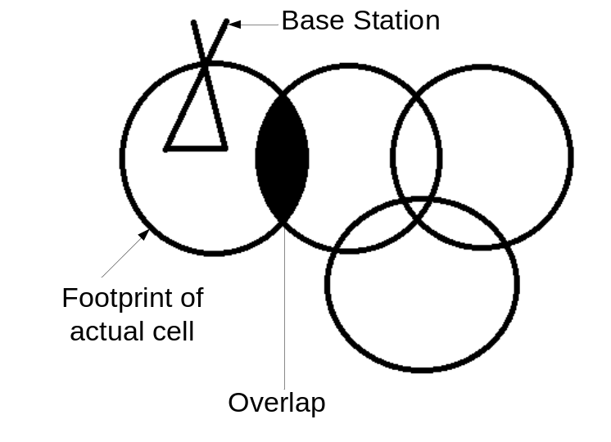

Cluster : Each cell is assign a frequency channel or group of channels. Adjacent cells are assigned non - overlapping frequency channels. Group of such cells with non- over lapping frequency is called a cluster. Size of the cluster (number of cells) can be 3, 4, 7, 9, 12, 21. The size of the cluster C , is according to shift parameters i and j.
i is step along one direction and j is step along another direction. C is given as:

C = i² + ij + j²

Typical values of C are given in the table below:

Cluster Size(C) | Values of i and j
C=1 | i=1, j=0
C=3 | i=1, j=1
C=4 | i=2, j=0
C=7 | i=2, j=1
C=9 | i=3, j=0
C=12 | i=0, j=2

Common Cluster sizes:
- GSM cluster size C = 3 and 4
- CDMA cluster size C = 1
- FM cluster size C = 7 or 9
F1

F3

F2
N = 3
F7

F8

F6

F1

F9

F5
F2

F4

F3

N = 9
F4

F1
F3

F2

N = 4
F6

F5

F1

F7

F4

F2

F3

N = 7

Same frequency (F1 and F1) can be assign to different cells in such a way that they are at a sufficient distance from each other and communication in this cell do not interfere with each other. Such cells are called Co-channel cells.
If number of cells in cluster is C then frequency reuse factor is 1/C. Distance between co-channel cells is called reuse distance

D

Frequency (F1)
Frequency (F2)
Cluster with cluster size 7
Co-channel cells
Reuse distance (D)
Reuse distance

This cluster can repeat itself and hence the same set of channels can be used again and again. By repeating the cluster in a systematic way the same frequency can be reuse in different area for a different transmission. As the number of times cluster is repeated increases capacity increase.
The closest distance between the co-channel cells (in different clusters) is determined by the choice of the cluster size and the layout of the cell cluster. The distance between the co-channels cells depends on size of cluster. More the number of cells in the cluster, more the co-channel distance
If cluster size is small number of time it will be repeated will be more hence capacity will increase. But if cluster size is small, the distance between co-channels cells will be less hence interference will be more. To tradeoff this situation, smallest cluster size for which interference can be tolerated should be taken. Larger cluster size demands for more number of unique channels hence number of channels allocated to each cells will be reduce decreasing the capacity.

Shape and Size of the Cell

Shape of the cell- Expected shape of the cell owing to the isotropic nature of the base station antenna should be a circle. Gaps results in loss of coverage and overlapping lead to interference of the signal. Therefore a polygon should be taken which can cover entire area without overlap and gaps and also it should rep geometry of circle. An equilateral triangle (all side equal), square or regular hexagon (all side equal) can be taken. They do not overlap or leave gaps. So the next criteria is the shape for which the area covered is maximum and also represent geometry of circle. The area of all the three shapes as compared to circle:

Equilateral triangle: 17.77 % of area of circle
Square: 63.7 % of area of circle
Hexagon: 83% of area of circle

Therefore hexagon is the ideal shape for a cell. In hexagon distance between center and the farthest point in the cell, a regular hexagon covers maximum area. Therefore regular hexagon is the ideal choice for shape of cell. This size is only the logical shape. In practice a cell exhibits irregular geometry.

Size of cell : The size of the cell can be controlled by controlling the power of antenna. The size of the cell depends on tele density and topography within a particular region.

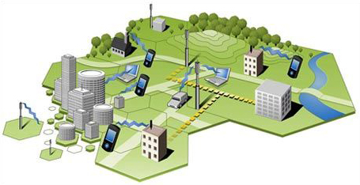
Figure : Cell sizes in suburbs are big whereas small in densely populated cities

By the increasing number of cells the overall capacity of cellular system. But if cells are made smaller, more base stations will be requested, increasing the cost.

According to size of cell, they are names as:

- Macro cells: - Macro cells used for remote or sparsely populated areas. Area of the cells are 10km or more in diameter . Used in suburbs of cities.

- Micro cells: - Micro Cells used in densely populate area with diameter around 10km.

- Pico cells: - Covers small areas like buildings, a small volley between mountains, a tunnel etc. where the coverage from large cells is not possible. Diameter is of few meters

- Selective cells: - Selective cells used when 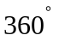degree coverage is not requested .They are used to fill the gapes/holes in the coverage of a BS.

Advantage of using small cells

- Higher capacity: - Huge cells allow limited number of users/km². Small cells can allow more users with the help of SDM, frequency reuse, FDM and frequency hopping.

- Low power Tx/Rx: - Power is a critical resource for mobile stations. Base stations can easily transmit high power so that the coverage area is increase but it has ill effects on the people surrounding it. Secondly mobile devices cannot do the same. Therefore small cells which requires only low transmit power are useful.

- Reduced Interference: - Small cells means less distance more the distance covered by antenna, more is the interference. Small cells covering small distance offer less interference.

- Robustness :- If a base station covering large area fails, it influence connection of many people where as if it is divided into small cells, failure of BS of small cell will effect communication within a small area only. Small cells offer a decentralized system.

Disadvantages of using small cells

- Large Infrastructure: - Smaller the cells, more the cells more BS are required and a complex infrastructure to connect these base stations are also required.

- Frequent Handover: - To provide uninterrupted services in form of cells or data, proper handovers are required. The frequent of handover would be more when he cell size is small and speed of movement is also more.

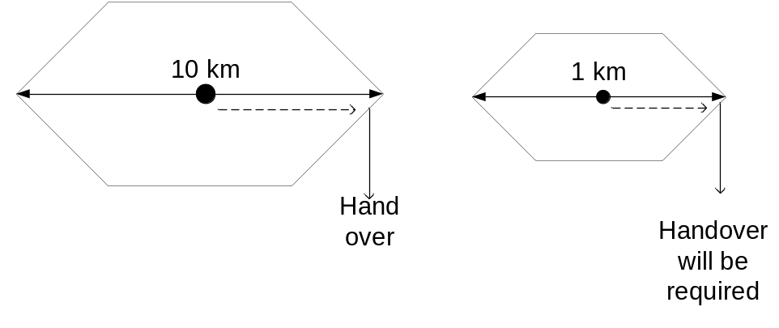

- Frequency Planning: - Smaller the cells, distribution of frequencies have to be done carefully to avoid the interference at the same time keeping in mind scarcity of frequencies.

Summary
Cellular systems were developed with the motive of replacing large high power antenna with small low power antennas so as to increase the spectral efficiency, reduce interference and allow more subscribers. It facilitates frequency reuse by repeating groups of cells called cluster in a systematic way. The ideal shape of cell should be hexagon as it covers maximum area and is closest to area of circle. Cell sizes depends on teledensity and topography of the area. Small cells increases capacity, interference and offers a decentralized robust system but requires frequent handovers and are complex to implement.

